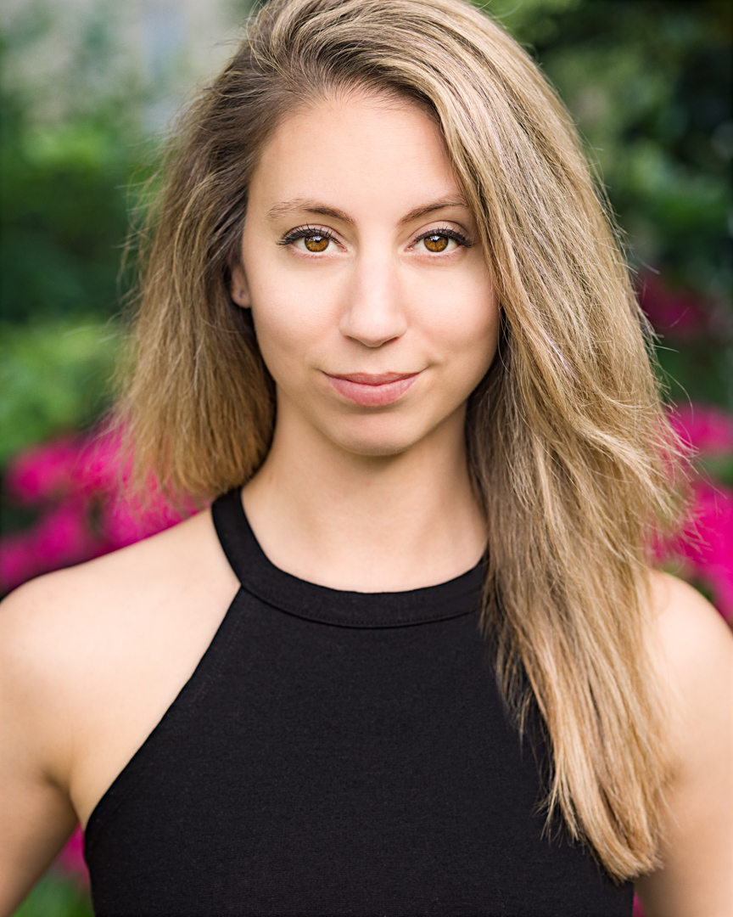
Chelsea Langevin
chelsea.langevin@gmail.com AEA Mezzo-Soprano to B flat / Belt
757-646-3326 Height: 5’4”

CRUISE LINE

Broadway In Concert Vocalist Norwegian Creative Studios
The Brill Factor Feat. Vocalist/Dancer Oceania Cruises
Dancin’ Fool Feat. Vocalist/Dancer
I Love Being Here With You Feat. Vocalist/Dancer

Musicology Feat. Dancer/Duet RWS Entertainment Group
Thousand Steps (Latin Ballroom) Feat. Dancer/Duet Holland America Line
One World Feat. Dancer
Off the Charts Swing

Disney’s Believe! Mainstage Dancer, Poca Pas u/s (performed) Disney Cruise Line
Golden Mickey’s Mainstage Dancer, Ariel u/s (performed) Disney Dream
Villain’s Tonight Swing (performed)

La Peregrina Feat. Dancer/Duet Mertz Productions
Songscape Feat. Dancer/Duet Viking Cruises
Song & Dance Feat. Dancer/Duet

THEATRE

An American in Paris Ensemble, Feat. Dancer (pointe/jazz & tap) Ogunquit Playhouse
(premiere regional production) Jeffry Denman

Jesus Christ Superstar Ensemble, Feat. Dancer North Carolina Theatre
Eric Woodall & Marc Kimelman

Mamma Mia! Ensemble; Ali & Lisa u/s (both performed) The Fireside Theatre
Ed Flesch & Kate Swan

West Side Story Velma; Anybody’s & Graziella u/s Theatre by the Sea
(original choreography) Bob Richard & Diane Laurenson

White Christmas Ensemble; Judy & Rita u/s Riverside Center for the Perf. Arts
Patrick A’Hearn, Artistic Dir.
DANCE

ALMA NYC Core Company member Zanza Steinberg, Artistic Dir.

“Dig It Up” Dancer Busch Gardens Williamsburg

“Voila!” & “Wunderbarn” Swing Busch Gardens Williamsburg

American Spirit Dance Co. Featured Dancer/Pointe Soloist OCU/Jo Rowan, Dir.

Kingdom World Premiere by Larry Keigwin UNC School of the Arts

The Nutcracker Pointe Soloist/Corps (8 years) Sandra Balestracci, Dir.

TRAINING

Oklahoma City University - BPA in Dance Performance; Jo Rowan, Chair

UNC School of the Arts - High School Diploma in Dance; Ethan Stiefel, Dean

Dance: STEPS, Broadway Dance Center, Keigwin & Co., Washington School of Ballet, Kaatsbaan

Voice: Rebekah Bruce Parker, Andrew Abrams, Drew Wutke, Jeffrey Picón, Brian Hamilton

SPECIAL SKILLS

Advanced Partnering & Lifts, Pointe, Tap, Ballroom, Flips in Aerial Swivel Harness, Spanish Web (flying & setting),

Very Strong Ballet Technique, Dance Captain, Wardrobe Supervisor, Passport (exp. 2/29), NC Driver’s License
www.chelsealangevin.com

